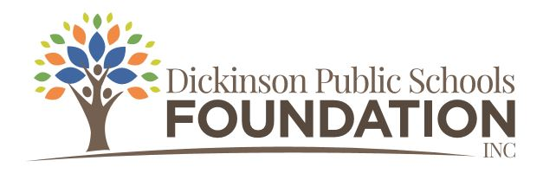

2022-2023 Mini Grant Application Form
This application form is used for DPSF Mini Grants.
(Grant applications must be typed.)
Mini grant applications may be submitted from October 1, 2022, through April 1, 2023.

Date: _________________

Project Title: ____________________________________________________________________

Contact Person: ____________________________ School/Building: _____________________

Position/Title:

Email Address:

Telephone #:

Please check: Certified Classified

Please check: Individual/Teacher Grade Level Team
Building Level/School-wide Team District-wide Team
Subject Area Team/Department
Other ____________________________________________________________

Collaborating partners (if applicable):
Name: ____________________________ Title: _______________ School: __________________
Name: ____________________________ Title: _______________ School: __________________
Name: ____________________________ Title: _______________ School: __________________
Name: ____________________________ Title: _______________ School: __________________

Amount Requested: $__________________

Which Foundation Focus area/areas applies to your grant? (Please check)

Academic Success College and Career Readiness Community
Cultural Early Childhood Professional Development
STEM/STEAM Student Wellness & Mental Health The Arts

Will the project be possible if we do not fund the project?

Beginning project date ______________ Ending project date _______________

Project Description/Overview

Briefly describe your proposed project.

What are the major goals of this project?

Why is your project needed?

How will the students’ educational experience be enhanced, improved or changed as a result of this project?

What will the project look like in action? Give a detailed explanation of what an observer would see.

Approximately how many students will be impacted by this project?

Technology Plan

Does your grant require technology? Yes No
If no, continue to Budget Summary. If yes, complete ALL questions in this section.

Who will install and/or set up software/hardware? Name: _________________ Title: ____________
Who will repair and/or replace software/hardware? Name: _________________ Title: ____________
Does your technology come with a service plan? Yes No
Does your technology require a license or subscription? Yes No
If yes, who will pay for the renewal fees? ___________________________________________
Does your grant require other technology or accessories to operate? Yes No
If yes, do you have it or a plan to acquire it? Please explain.

I understand the district technology department is not responsible for installing, updating, licensing, repairing, or replacing any technology obtained from this grant.

If applicable, I have completed the district’s “Software Purchase Request” form. This will be taken into consideration for grant approval. Please note the Foundation retains the right to make the final decision.

Budget Summary (include itemized expenses for material/equipment)

Describe the proposed project budget. State specifically how the money will be used.
Example: List all books, equipment, materials, software to be purchased along with prices, service plan, shipping costs, etc. Mini grants up to $500 will be accepted. Any expenditures above $500 must come from building or personal funds.

Item Description Quantity Unit Price Total Cost
Shipping/handling costs:

Total Project Cost: $_________________________

Applicant’s signature(s):_______________________________________________________________
__________________________________________________________ Date: ___________________

Building administrator’s signature: ______________________________ Date: __________________

For Foundation use only:

Date application was received: ___________ Application received by: ______________________

Approved (Yes or No) ______________

If not, why?

Check sent? __________ When? ____________

