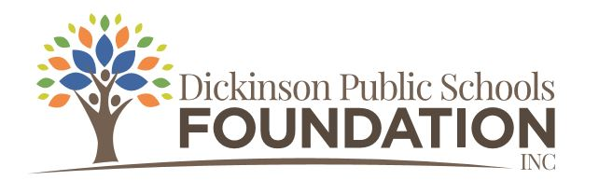

2021-2022 Mini Grant Application Form

This application form is used for DPSF Mini Grants.
(Grant applications must be typed. Send hard copy to Karen Heidt % DPS Foundation.)

Mini grant applications may be submitted from October 1, 2021, through May 1, 2022.
Funding will depend if budgeted funds are still available.

Date: _________________

Project Title: ____________________________________________________________________

Contact Person: ____________________________ School/Building/s: _____________________

Position/Title:

Email Address:

Telephone #:

Sponsoring School Building (if applicable): ____________________________________________

Please check: Individual/Teacher Grade Level Team
Building Level/School-wide Team District-wide Team
Subject Area Team/Department
Other ____________________________________________________________

Other Partners Collaborating On Project (if applicable):
Name: ____________________________ Title: _______________ School: __________________
Name: ____________________________ Title: _______________ School: __________________
Name: ____________________________ Title: _______________ School: __________________
Name: ____________________________ Title: _______________ School: __________________
Name: ____________________________ Title: _______________ School: __________________

Amount Requested: $__________________

Which Foundation Focus area/areas applies to your grant? (please check)

Academic Success College and Career Readiness Community
Cultural Early Childhood Professional Development
STEM/STEAM Student Wellness The Arts

Attach proposed budget summary. Mini grants up to $500 will be accepted. Include Itemized expenses. State specifically how the money will be used. List all books, equipment, materials, software, etc. to be purchased along with prices and shipping costs.

Will the project be possible if we do not fund the project?

Beginning project date ______________ Ending project date _______________

Project Overview
Briefly describe your proposed project.

What are the major goals of this project?

Why is your project needed?

From the teachers’ perspective, how will this grant assist you in being more effective?

From the students’ perspective, how will their educational experience be enhanced, improved or changed as a result of this project?

How will you evaluate the effectiveness of this project?

What Dickinson Public Schools students will benefit from this project?

Approximately how many students will be impacted by this project?

Date: ____________ Applicant’s signature (s): __________________________________________________________________________________
__________________________________________________________________________________

Date: _____________ Building principal/administrator's signature: _________________________

For Foundation use only:

Date Application was received: ___________ Application Received by: ______________________

Approved (Yes or No) ______________
If not, why?

Check sent? __________ When? ____________

